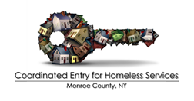

Case Conference Request Form
**Please email completed form to Heidi Markham, hmarkham@letsendhomelessness.org**

Requestor Information
Name
Agency
Phone
Email

Client Information (ONLY shared with Coordinated Entry and CoC; NOT with case conference attendees)
Name
HMIS #

Please provide a summary of the reason(s) why a case conference is being requested and what you would like to achieve by conducting a case conference.

What steps have been taken to address the concerns noted in the summary above?

Please list all relevant parties that need to be involved in this case conference.

For questions or if you need more information, please contact:

Heidi Markham | Prioritization List Coordinator
Partners Ending Homelessness
C: (585) 866-9375 | hmarkham@letsendhomelessness.org

ADMIN USE ONLY
Date request received

Case conference approved | ☐ YES ☐ NO
Case conference ID #

Date of case conference

Other attendees invited

